Seventeenth session of the North Eurasia Climate Outlook Forum
(NEACOF-17)
November 2019, Moscow

Consensus Statement

In mid-November 2019, the 17th session of the North Eurasia Climate Outlook Forum (NEACOF-17) was held on the basis of Internet resources with the participation of representatives of the Meteorological services of Russia and the CIS countries. The forum discussed the main features of atmospheric circulation in June-August 2019, the skill score of forecasts of air temperature and precipitation anomalies for June-August 2019, the expected conditions of the SST in ocean and large-scale atmospheric circulation pattern for the upcoming boreal winter season 2019/2020. Following the traditions of NEACOF, a consensus forecast of surface air temperature and precipitation anomalies in Russia and the CIS was developed using an objective approach, and based on the results of hydrodynamic modeling from five forecast centers (model of the Hydrometeorological Center of Russia / INM - PLAV, model of Main Geophysical Observatory, CanSIPSv2 model of Canadian Weather Service ECCC / MSC, model of the TCC Tokyo Climate Center, model CFSv2 of the Climate Prediction Center, CPC NOAA USA).

The main features of atmospheric circulation in June-August 2019

In the summer of 2019, in the stratosphere of the high latitudes of the Northern Hemisphere (Fig. 1a) the typical summer circulation has been observed, which corresponded to an intense stratospheric anticyclone over the pole.

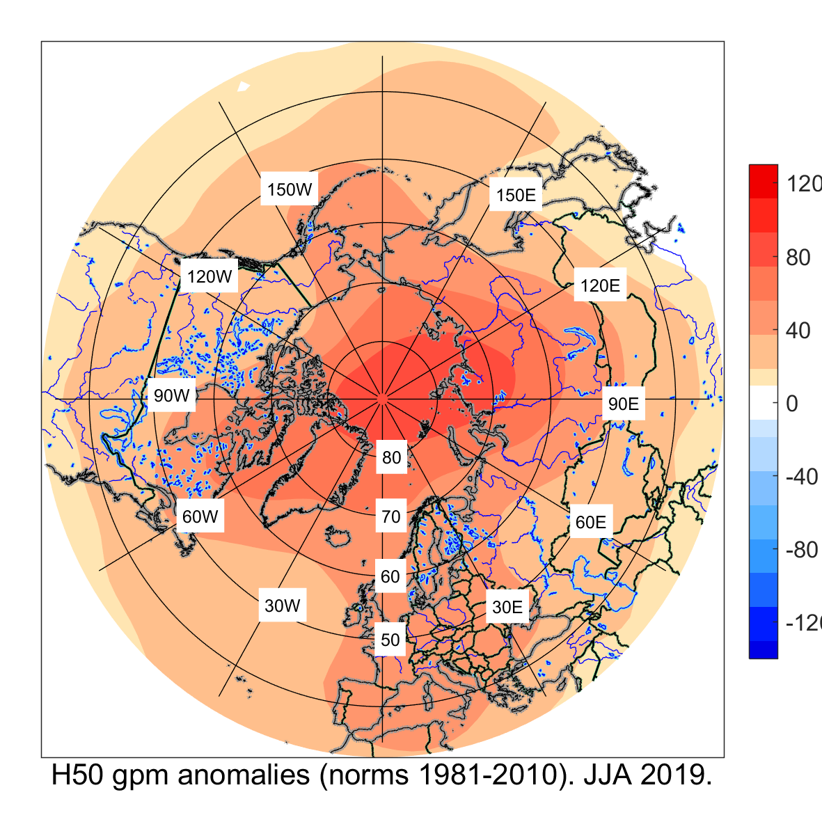  а) | 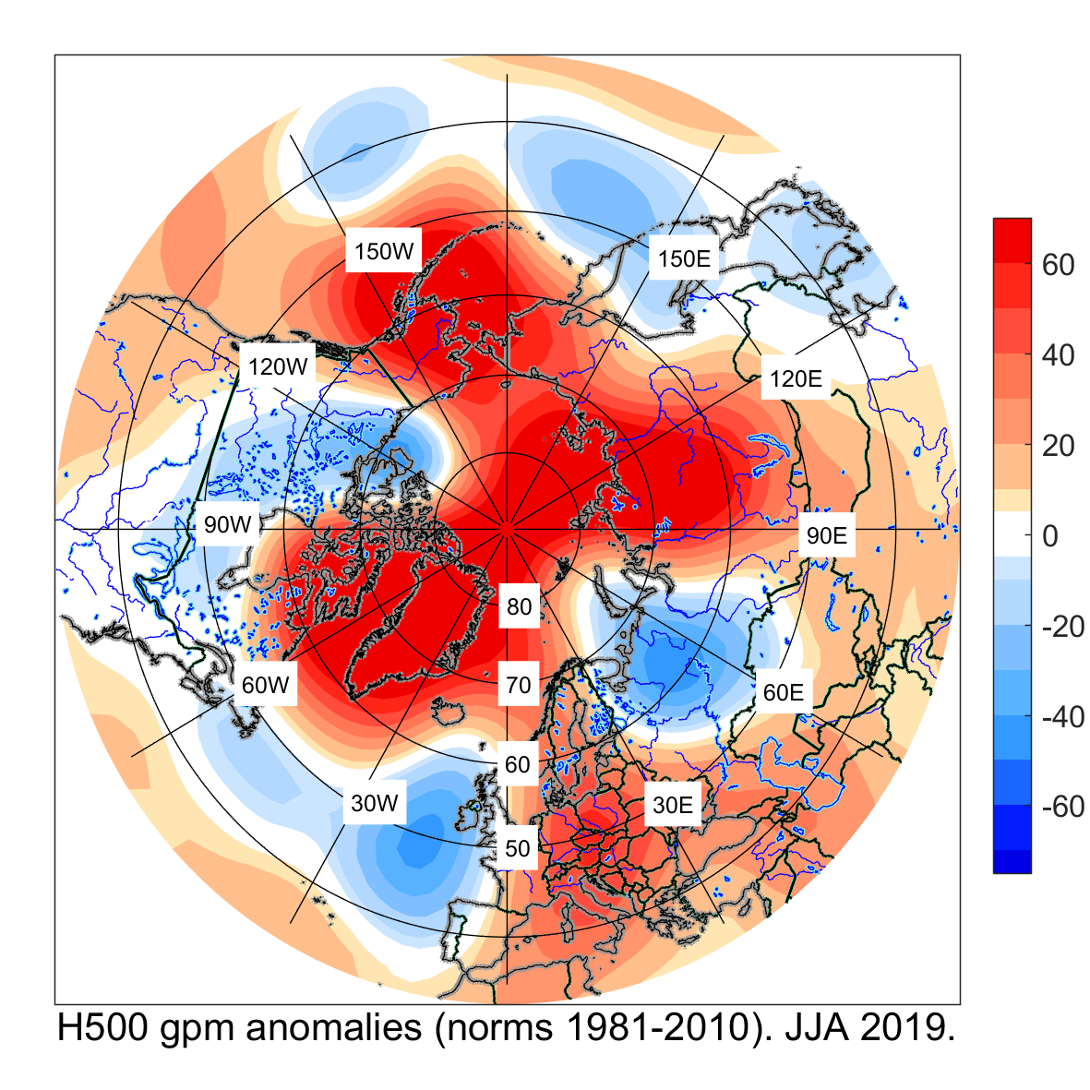  b) | 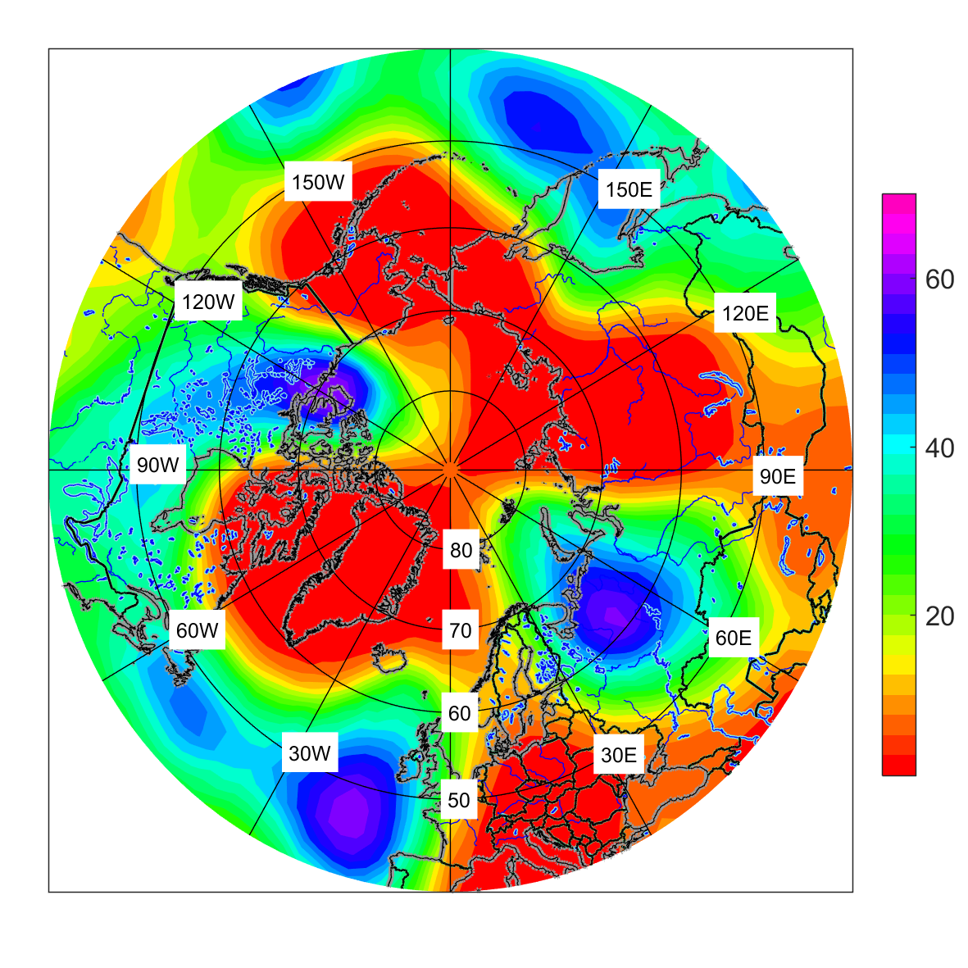  c)
Figure 1. June, July, August 2019 anomalies of a) geopotential H-50, b) geopotential H-500, based on the 1981-2010 reference period and c) ranks of geopotential H-500. Source: NCEP / NCAR reanalysis data

The center of the anticyclone above the pole was in climatic position; its ridges spread throughout Europe, Siberia, Alaska, and the eastern part of Canada and Greenland. In the geopotential field in the middle troposphere, at the H-500 (Fig. 1b), tropospheric anticyclones were observed over Europe, Siberia, over the North Pacific and the Arctic seas. The seasonally averaged geopotential values ​​at the center of anticyclones were near record. (Fig. 1c) The main climatic feature in the summer season was the weakening of the polar tropospheric vortex and its splitting into two centers. This circulation conditions contributed to the strengthening of meridional processes and the formation of blocking conditions in the atmosphere. Tropospheric through extended over the territory of European Russia and Canada.

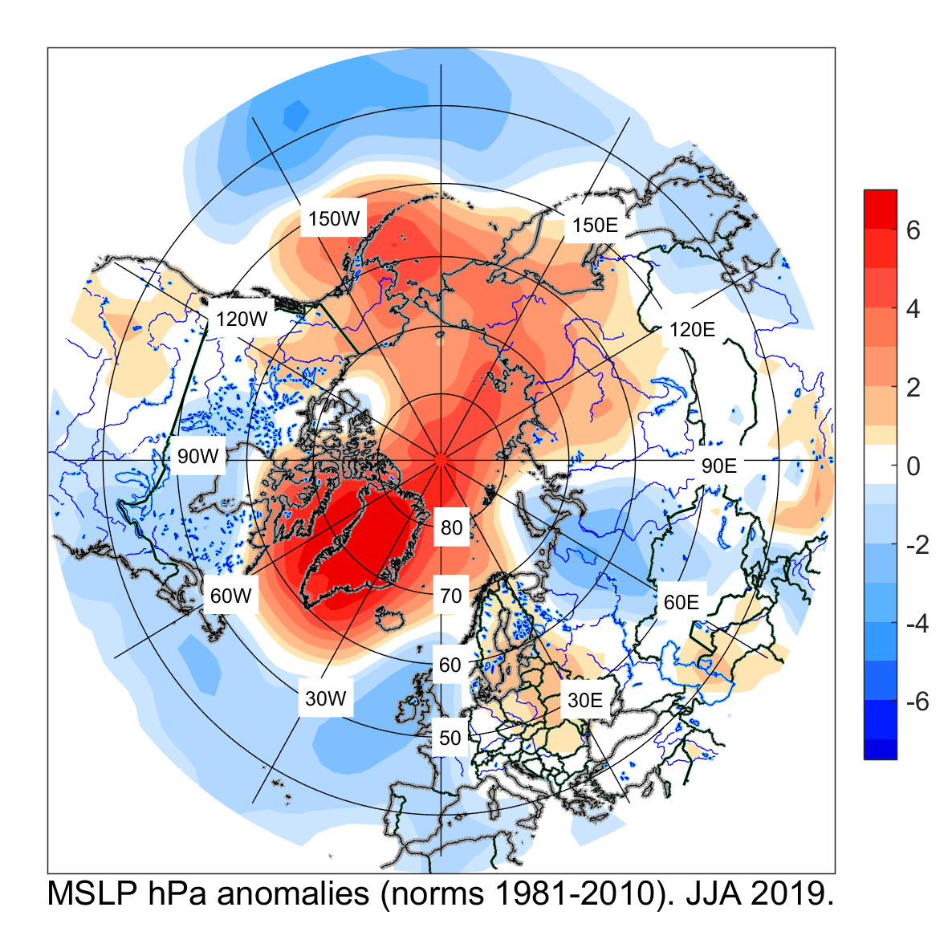  а) | 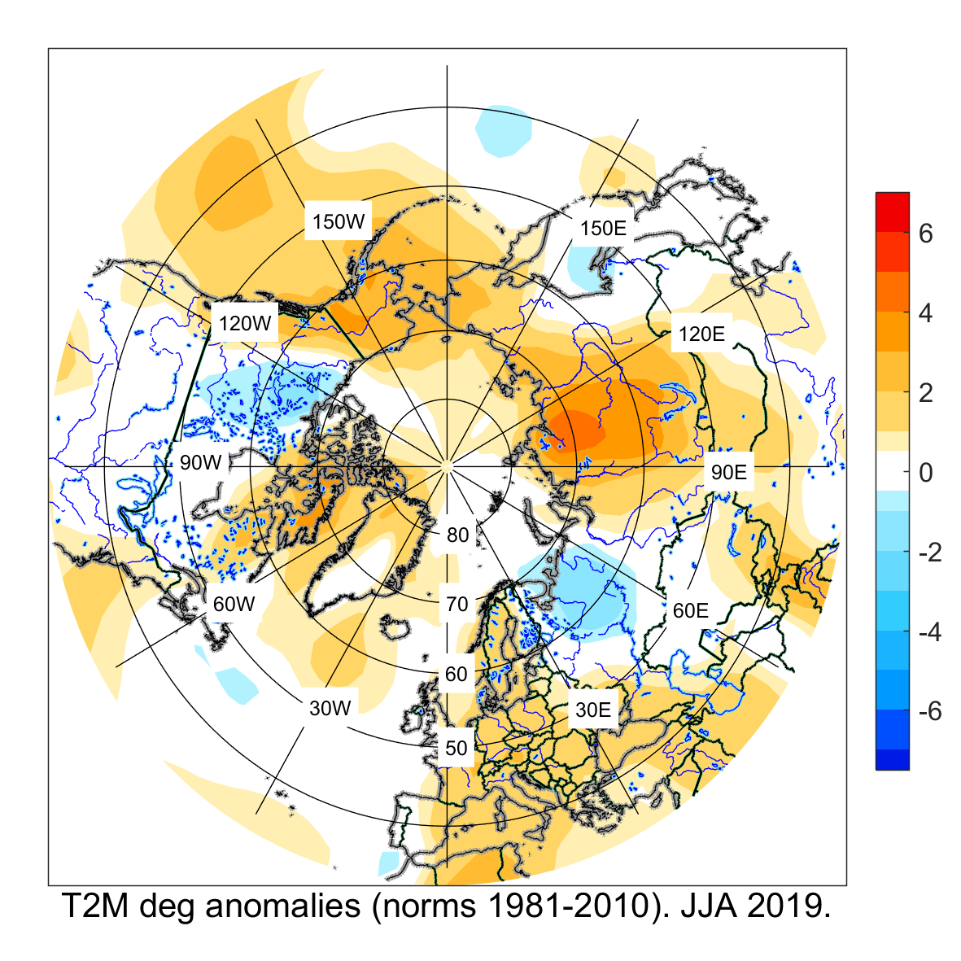  б) | 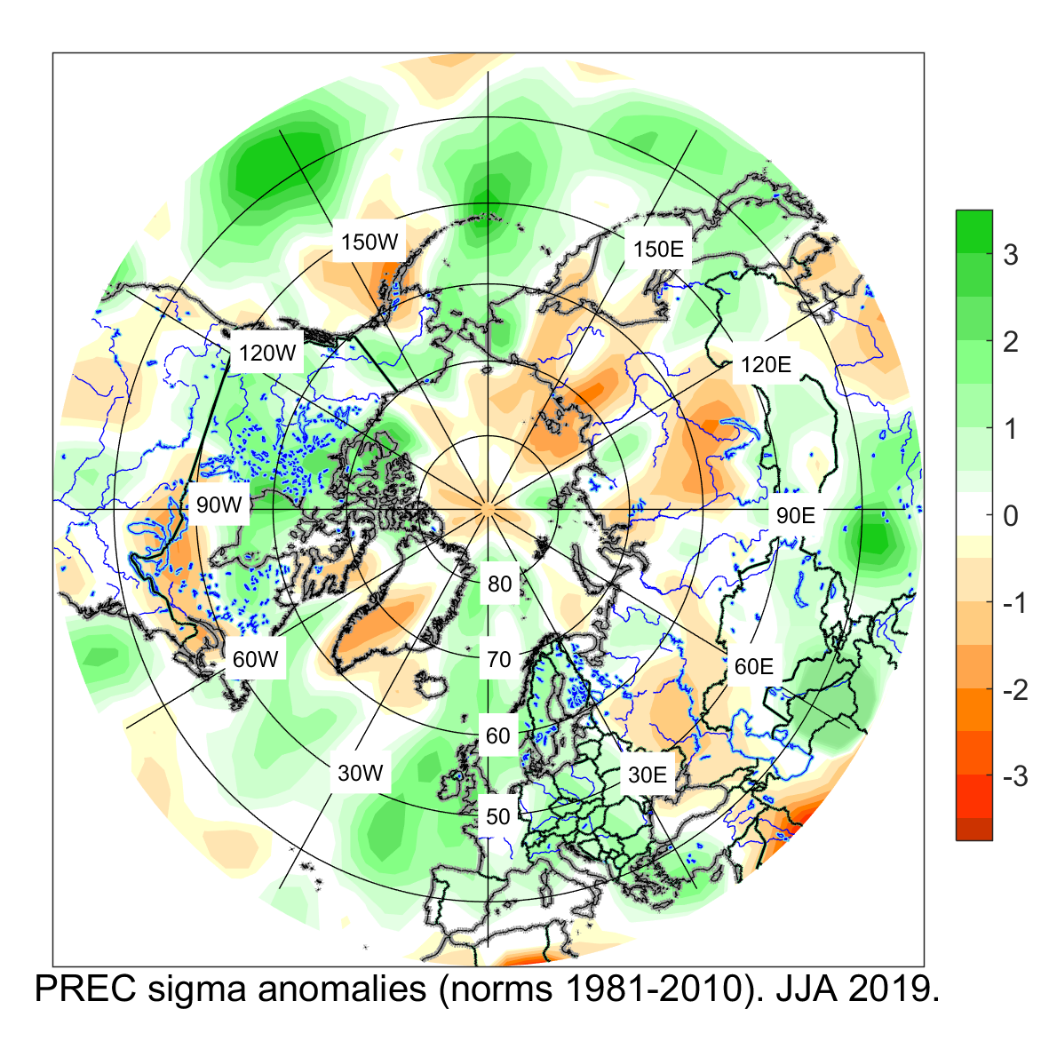  в)

Figure 2. June, July, August 2019 anomalies of a) mean sea level pressure, b) air temperature, and c) precipitation based on the 1981-2010 reference period. Source: NCEP / NCAR reanalysis

Positive anomalies of atmospheric pressure prevailed (Fig. 2a) during summer 2019 over the largest part of Europe, Siberia, and the North Pacific. The highest values ​​of atmospheric pressure were observed over Greenland. In most of Siberia and the Far East, precipitation deficit was observed (Fig. 2c) with above normal air temperatures. The record temperature anomaly for the summer season was observed in the Eastern Siberia (+ 2.9 ° С). Over the central and southern regions of the European territory of Russia and the Urals, the air temperature was close to the norm of 1981-2010. Cyclonic activity was recorded over the European territory of Russia, the Urals and in the south-west of Siberia. Negative pressure anomalies under the influence of post-tropical cyclones were observed in the south of the Far East. In the north of the European territory of Russia, under the influence of cold advection in the rear parts of cyclones, the air temperature turned to be below normal (Fig. 2b), and precipitation exceeded the norm. Active cyclonic activity in the south of Siberia contributed to the formation of negative surface pressure anomalies, which caused an excess of precipitation, and in some areas led to flooding. Precipitation above the norm was observed over Chukotka due to the shift of the Aleutian minimum to the west.

Verification of forecasts of air temperature and precipitation for June-August 2019
The consensus forecast (Fig. 3a) realistically reproduced the prevalence of positive anomalies over the north-eastern part and the south of the European territory of the CIS, over western and eastern Siberia. The largest anomalies in the north of Siberia were reproduced correctly. The near norm air temperature was predicted over the Ural and Volga federal districts and over the Far East, however, according to NCEP/NCAR reanalysis data (Fig.3b), negative temperature anomalies were observed in these regions. The dominance of near norm temperature ​​in Central Asia is correctly reproduced in the consensus forecast, except some regions in the north and west. In the southeastern regions of Central Asia, a positive anomaly of average temperature was observed, while temperature was predicted to be near normal.

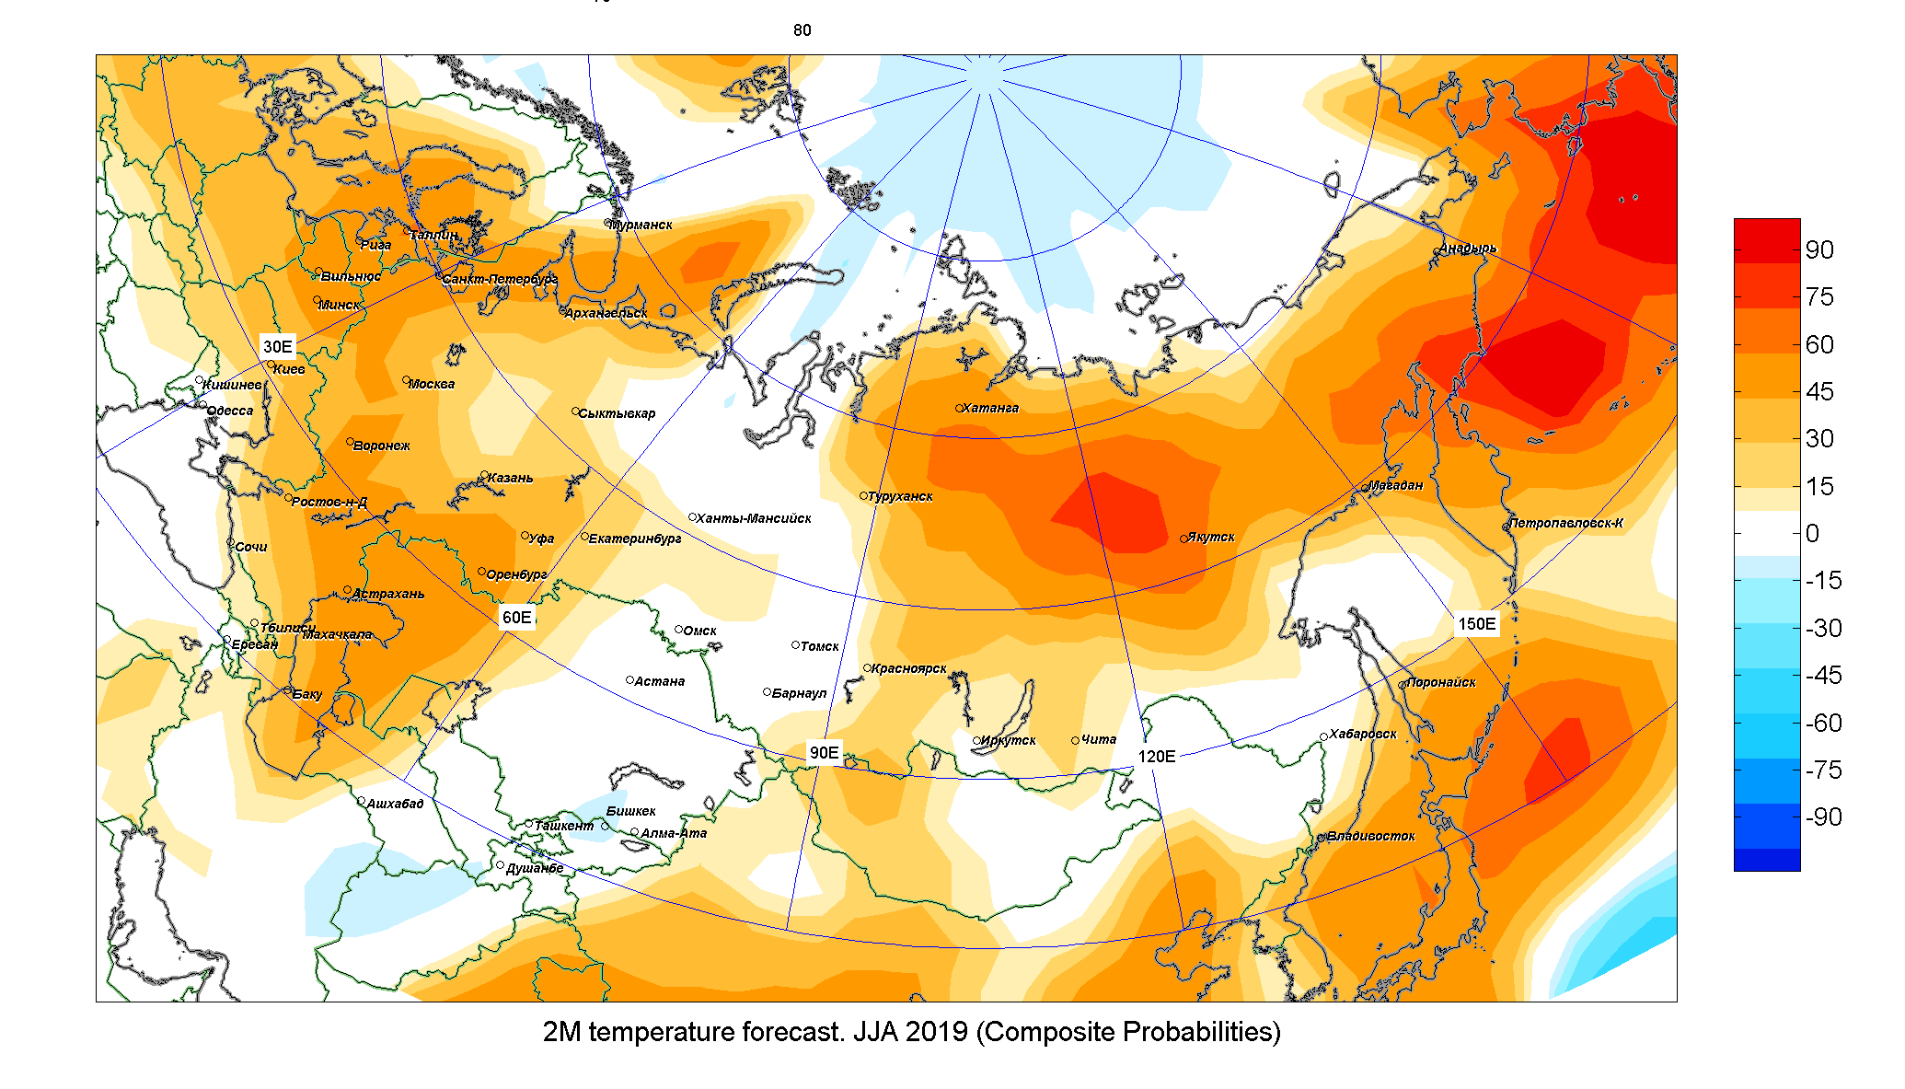 | 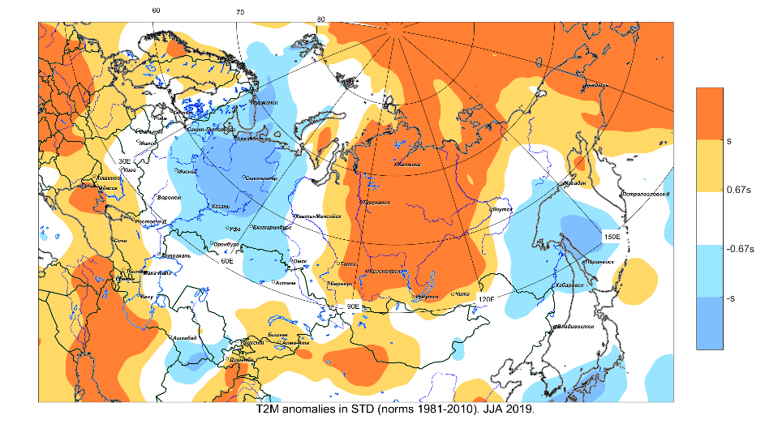
а) б)
Figure 3. Distribution of surface air temperature anomalies from a) consensus forecasts b) NCEP / NCAR reanalysis data for the June, July, August 2019.
The consensus forecast correctly predicted a deficit of precipitation over the European territory of Russia (Fig. 4a), in the north of Western Siberia, over some regions of Eastern Siberia. The loactions of the largest precipitation anomalies over Chukotka and the Far East are reproduced correctly. An excess of precipitation was predicted over the vast regions of southern Siberia, but from NCEP/NCAR data precipitation was below normal (Fig. 4b). The precipitation field in Central Asia was reproduced well with the exception of the northeastern region.
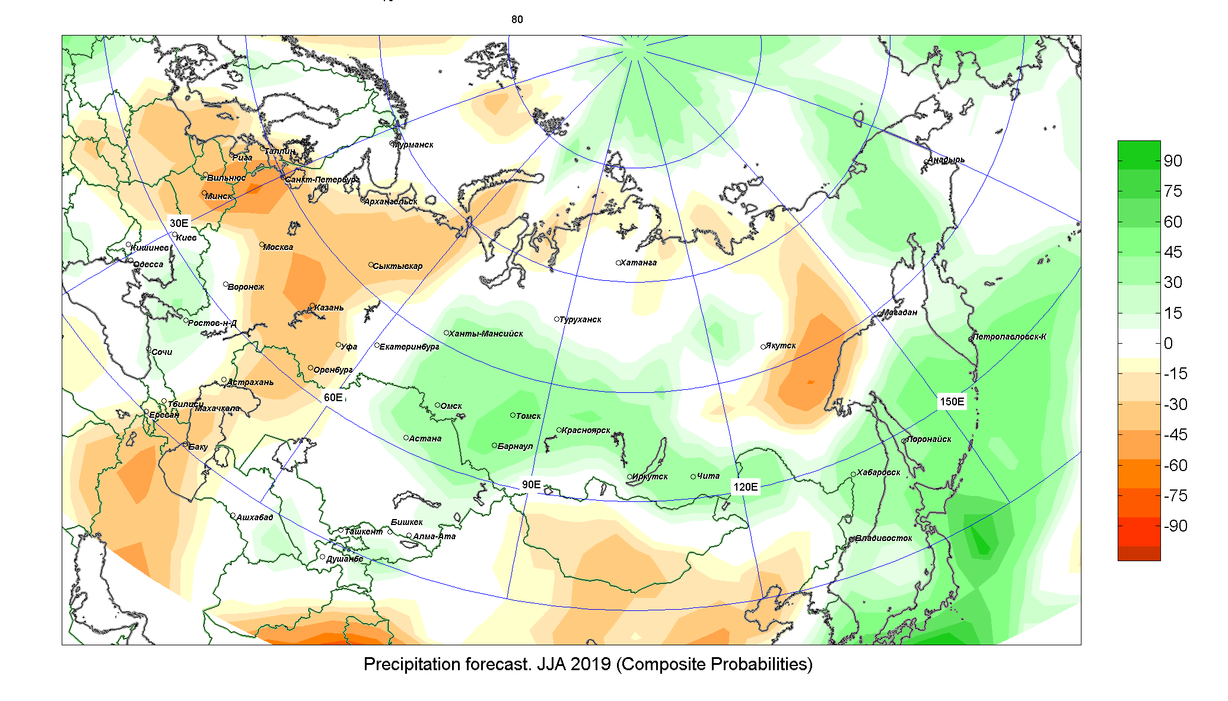 | 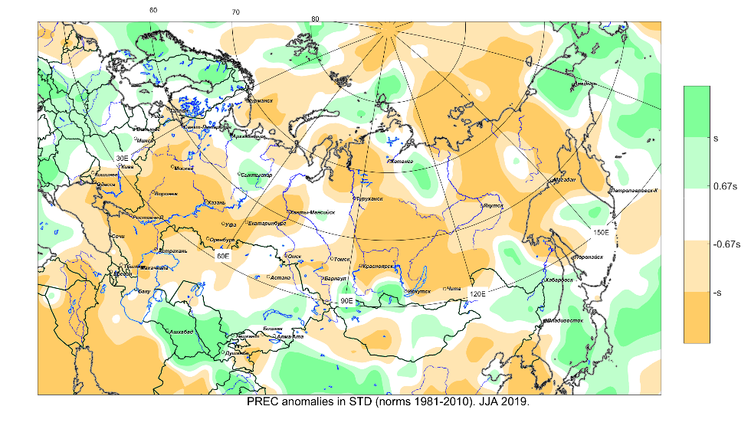
а) б)
Figure 4 Distribution of precipitation anomalies from a) consensus forecasts b) NCEP / NCAR reanalysis data for the June, July, August 2019.

Table 1. Skill score of forecasts (%) for June-August 2019

 | North Eurasia (NE) | European part of NE | Asia part of NE | Central Asia
T2m | 76 | 70 | 81 | 73
Prec | 72 | 73 | 70 | 72

The skill score of consensus forecast throughout the territory of North Eurasia for air temperature was 76%, for precipitation - 72%.

The main features of the SST (sea surface temperature) of the ocean and large-scale atmospheric circulation for the upcoming winter 2019/2020.

For the upcoming winter season of 2019/2020, most forecast centers predict significant anomalies of SST in the North Pacific. Positive (negative) anomalies are expected in the west and east (in the center) of the North Pacific, which can lead to a change in the intensity and geographical position of the main centers of action of the atmosphere - the Hawaiian anticyclone and the Aleutian minimum. According to IRI / CPC forecasts, the probabilities of the events of La Nina, neutral phase and El Nino (Nino3.4, threshold values: -0.5 ° C and 0.5 ° C) in the coming winter season: 5%, 67% and 28%. In the North Atlantic, the distribution of prognostic anomalies corresponds to the positive tripole phase associated with the positive NAO phase. Significant positive SST anomalies are expected in the Gulf Stream and Iceland, as well as in the North and Norwegian Seas. According to forecasts of most centers, a positive phase of the North Atlantic Oscillation (NAO) is expected in the coming winter. Positive values ​​of the NAO index are associated with positive air temperature anomalies in northern Europe and negative in southern Europe. The winter season 2019-2020 is expected to be warmer than usual in most of Northern Eurasia, according to the forecasts of most models. Negative or near normal temperature values ​​are most likely in the south of Siberia and in Central Asia. Precipitation forecasts have many contradictions and uncertainties. Most models predict excess moisture in the north of Siberia and the Far East, ECMWF predicts - precipitation deficit in the south of Eastern Siberia and the Far East.

Consensus forecast of anomalies of surface air temperature and precipitation for the DJF 2019/2020.

In the winter of 2019/2020, over Western Siberia, in the northeast of Yakutia and in the Chukchi region, the temperature regime is expected to be above normal ​​with a probability of about 60%. In the south of Siberia, temperature anomalies might be higher than normal. An increased air temperature anomaly with a probability of about 40% is predicted in Uzbekistan, Turkmenistan, Kyrgyzstan, in the south of Kazakhstan and in the north of Tajikistan. In the CIS countries on the European part of NE, positive temperature anomalies are likely to be. Over the rest of Russia and the CIS, forecasts of air temperature anomalies have a large degree of uncertainty.
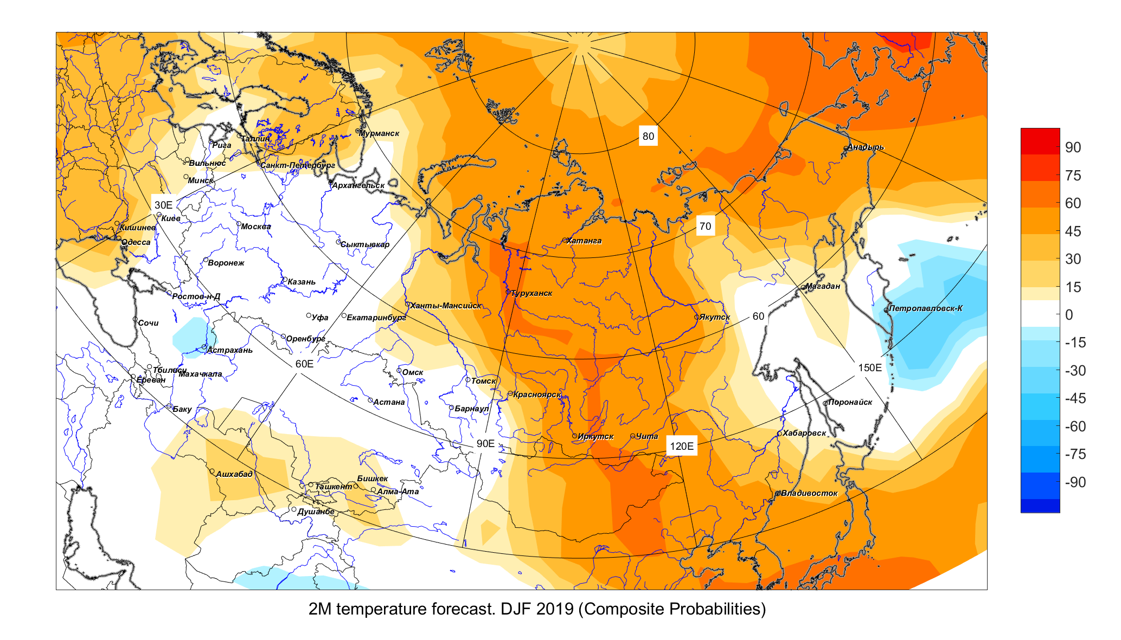

Figure 5. DJF 2019 consistency map of air temperature anomaly forecast based on 5 weighted models. Positive (negative) values (in %) mean the number of models with weights that predict positive (negative) anomalies of surface air temperature.
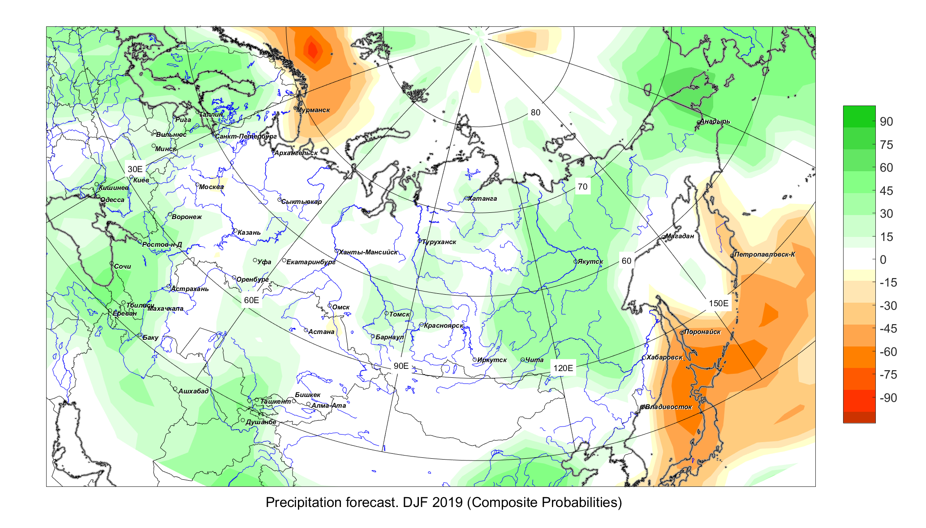
Figure 6. DJF2019 consistency map of precipitation anomaly forecast based on 5 models. Positive (negative) values (in %) mean the number of models with weights that predict positive (negative) precipitation anomalies.
Above normal precipitation is expected over most of Siberia. In the south of the European part of Russia, the precipitation is likely (~ 50%) to exceed the norm. An excess of precipitation with a probability of 35-45% is forecasted in the central and southern regions of Central Asia.
The consensus forecast is advisory information and can be applied to specific regions, taking into account the predictability of atmospheric processes, regional climatic features̆ and the quality of hydrodynamic models̆ used.

