Eighteenth Session of the North Eurasian Climate Forum (NEACOF-18)
May 19-20, 2020
Сonsensus statement
Introduction
Fulfilling the international responsibilities of the Regional Climate Centre of WMO, the North-Eurasian Climate Centre (NEACC) held online the 18th session of the North-Eurasian Climate Outlook Forum (NEACOF-18) from 19 to 20 May 2020 on the base of the Hydrometcentre of Russia.
The first day of NEACOF-18 (May 19, 2020) was organized in the form of a training seminar. The lectures of leading NEACC experts were presented, each concluded by follow-up discussions on the development of methods and technologies of climate forecasting, analysis and predictability of atmospheric variability, and practical use of climate information.
On the second day of NEACOF-18, climate monitoring and seasonal forecasting issues were discussed based on the input from NHMSs of the CIS countries and other forecast centres with the main goal of developing a consensus forecast of surface air temperature and precipitation for the upcoming summer season 2020 over northern Eurasia.
NEACOF-18 gathered representatives of Secretariat of the WMO, specialists from the Hydrometcentre of Russia, A.I. Voeikov Main Geophysical Observatory, Arctic and Antarctic Research Institute, Regional Training Centre of WMO in Roshydromet. NHMS of Armenia, Belarus, Kazakhstan, Kyrgyzstan, Moldova, Russia, and Uzbekistan.
The main features of atmospheric circulation in DJF 2019/2020

An intensive and deep circumpolar vortex in the stratosphere with the centre over the Franz Josef Land was observed during DJF 2019/2020. The geopotential in the centre of the cyclone was significantly lower than normal (the average seasonal anomaly was about -90 dam). The startospheric cyclone had been stable and cold until a sudden stratospheric warming event occurred in March 2020. Such conditions led to the formation of polar stratospheric clouds and, judging by preliminary estimates, to a record-breaking depletion of the ozone layer in the Arctic since 2011. Stratospheric anticyclones over the North Pacific Ocean were intensive, and often spread to the western and central regions of the USA and Canada during the season. The maximum values of positive anomalies were over central Canada where they reached + 38 dam (Fig. 1a).
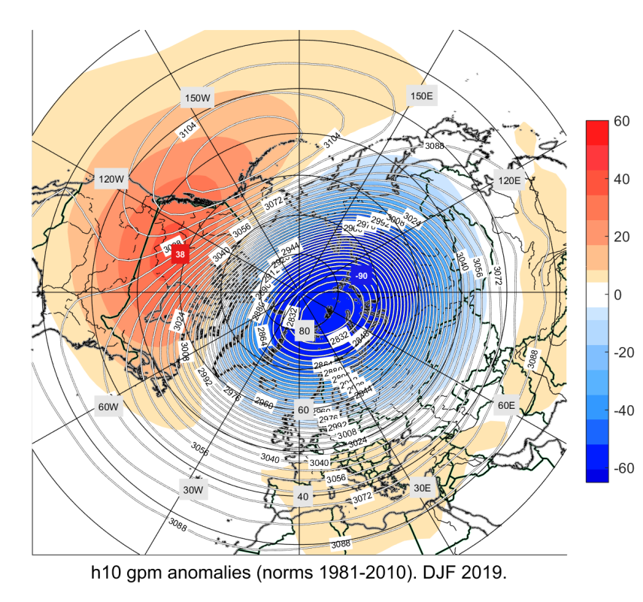  a) | 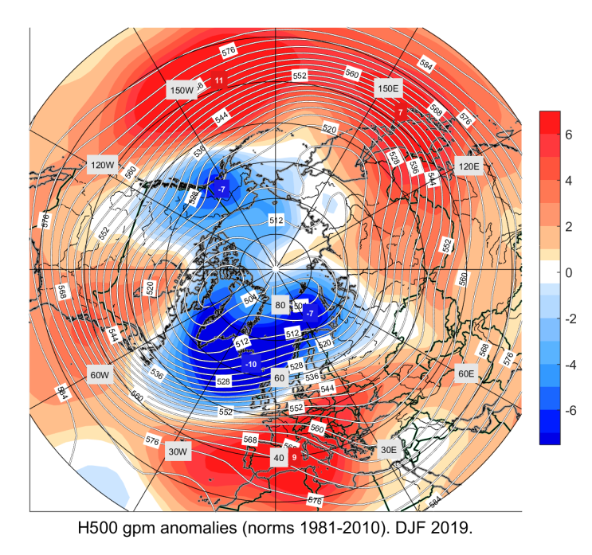  b) | 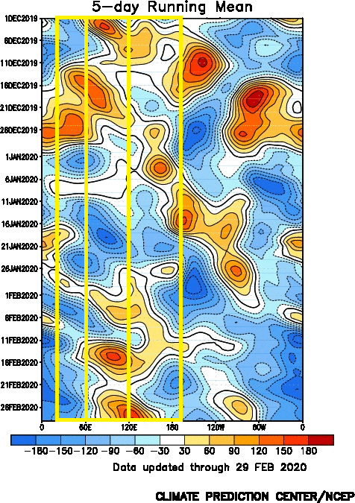  c)
Figure 1. Maps of anomalies of geopotential with reference to 1981-2010 and absolute values based on NCEP / NCAR reanalysis, DJF 2019/2020 a) at the H10 hPa, b) at the H500 hPa (source: NEACC) c) long-term-time diagrams of geopotential anomalies with 5 days running means(1981-2010) for the latitudinal section of 60-90 ° N. (source: CPC NOAA)

Throughout the winter, the phase of the NAO index remained positive and abnormally high positive values of the AO index were recorded in January and February. Zonal atmospheric circulation prevailed over the territory of Northern Eurasia. The circumpolar cyclone split in two centres: the first in the Canadian sector of the Arctic, namely, in the Baffin Sea, the second, over the Franz Josef Land archipelago. The troughs extended to the European part of Russia, the Urals and the north of Western Siberia. The trough over the north of the Pacific Ocean was slightly shifted to the east and located over Alaska. Tropospheric ridges were situated over the southwestern part of Europe, the Western and Central parts of Siberia, and in the north of the Pacific Ocean. (Fig. 1b) From the end of December to the end of January, Europe and the ETR were influenced by tropospheric ridges, and the strongest blocking processes took place in mid-January. In February, blocking activities were observed as far as in Siberia, and over the ETR as well in the middle of the month (Fig. 1c).

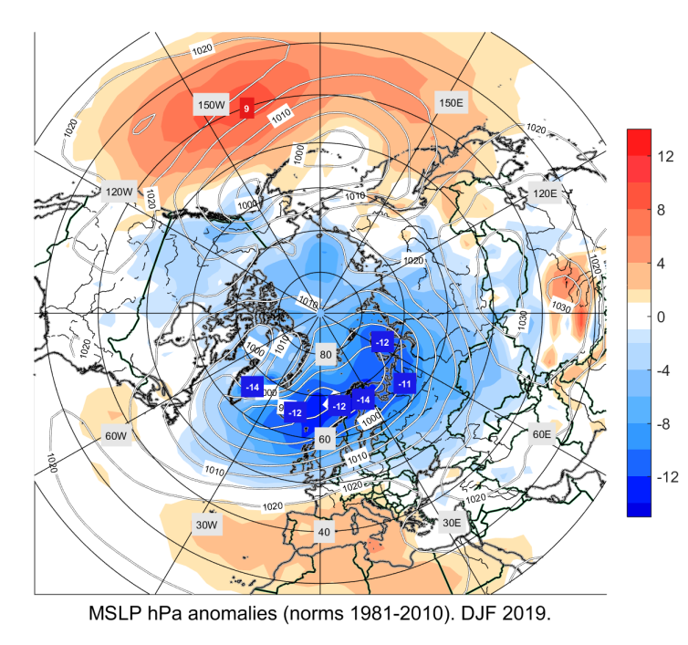  а) | 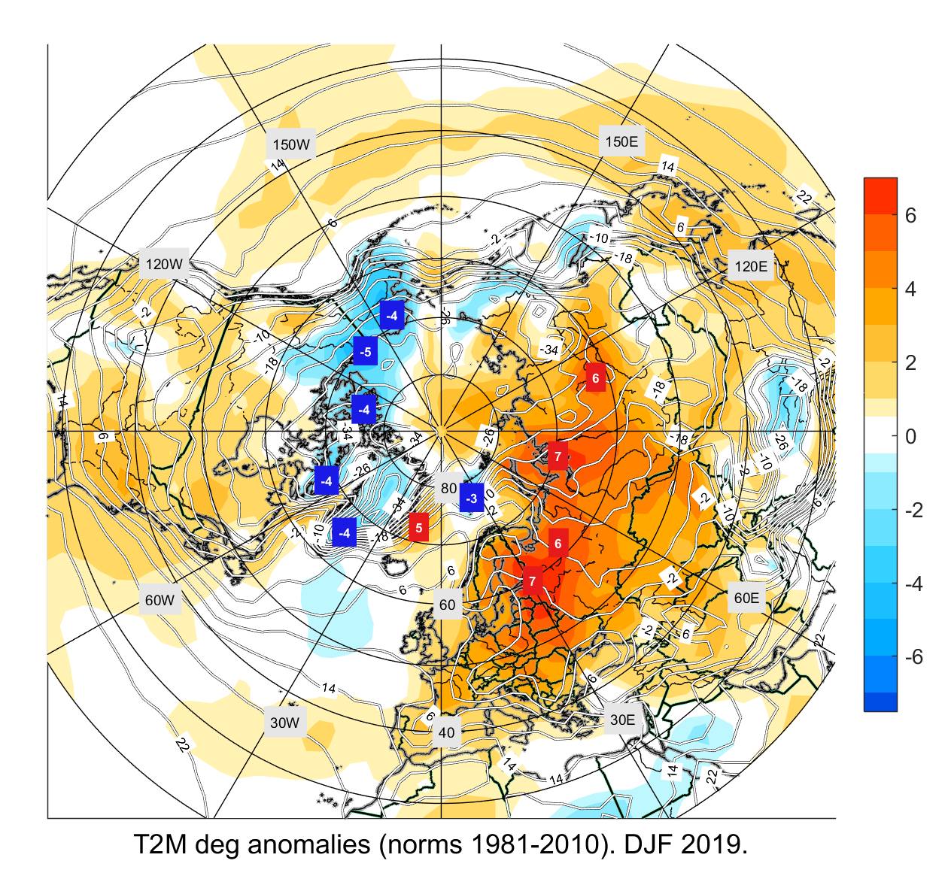  б) | 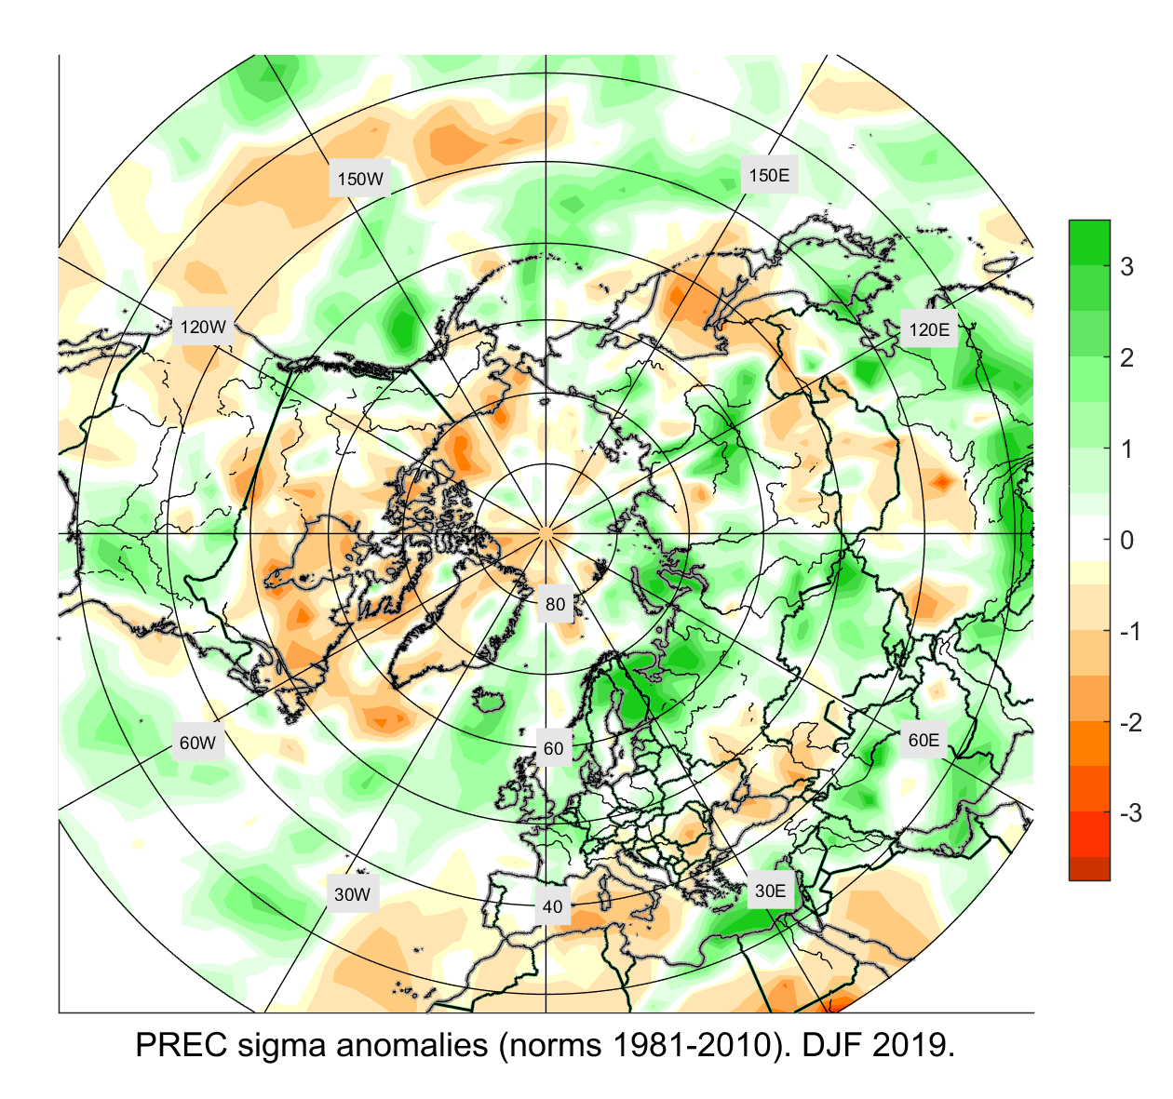  в)

Figure 2. Maps of anomalies relative to the climatic norms for 1981-2010 as per the NCEP/NCAR reanalysis data and the measurements of: a) surface pressure, b) surface air temperature, c) precipitation; DJF 2019/2020

As for the Atlantic pair of centres, the minimum centred in the region of Iceland was most powerful.
The deep through over Eastern Europe was observed with the largest negative anomalies up to -14 hPa in northern Scandinavia. The second through was located over Western Siberia. The Siberian maximum was weaker than normal, located over Mongolia and covered a slightly smaller area. The western periphery of the Siberian maximum was weak, while the north-eastern and eastern ridges of the Siberian anticyclone were strong (Fig. 2a). Over the whole territory of Eurasia, the temperature was significantly higher than normal (anomalies up to 4-7°) (Fig. 2b). The largest positive anomalies (7 °) were in the north-west of the European part of Russia and in the north-west of the Krasnoyarsk region. According to the Hydrometcentre of Russia, the winter 2019/ 20 became the warmest in the history of Russia, exceeding the previous record of 2015/16 by 1.3°C. Excess precipitation under the influence of deep Atlantic cyclones was recorded in Scandinavia, in the north of the European part of Russia, in the north of the Urals, and in the north of Western Siberia. Precipitation was below normal in the south of the ETR and in the west of Kazakhstan, and above normal in the eastern half of Kazakhstan, Kyrgyzstan and Turkmenistan. Under the influence of the Siberian maximum, abnormally low amounts of precipitation were observed in the south of Eastern Siberia, in Mongolia and in the south of the Russian Far East, and on Sakhalin Island.

Verification of forecasts of air temperature and precipitation for DJF 2019/2020

The forecast correctly reproduced the positive anomalies of air temperature over the western regions of the northern Eurasia, in the southern half of Central Asia (Turkmenistan, Uzbekistan, Tajikistan, Kyrgyzstan, southern Kazakhstan), over Siberia. In most of the ETR, the forecast and the observed anomaly were in adjacent categories of ratings (e.g., "near normal" forecasted, "above normal" observed). (Fig. 3)
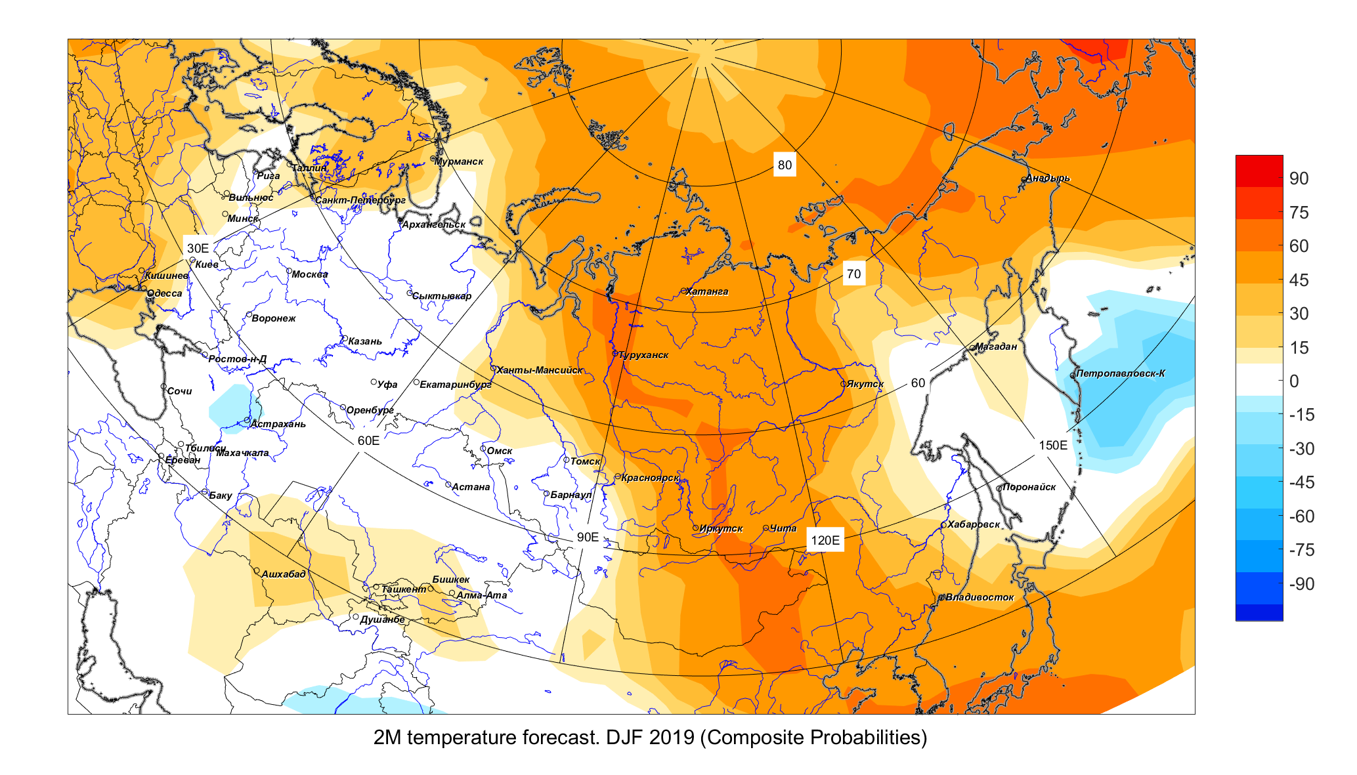  a) | 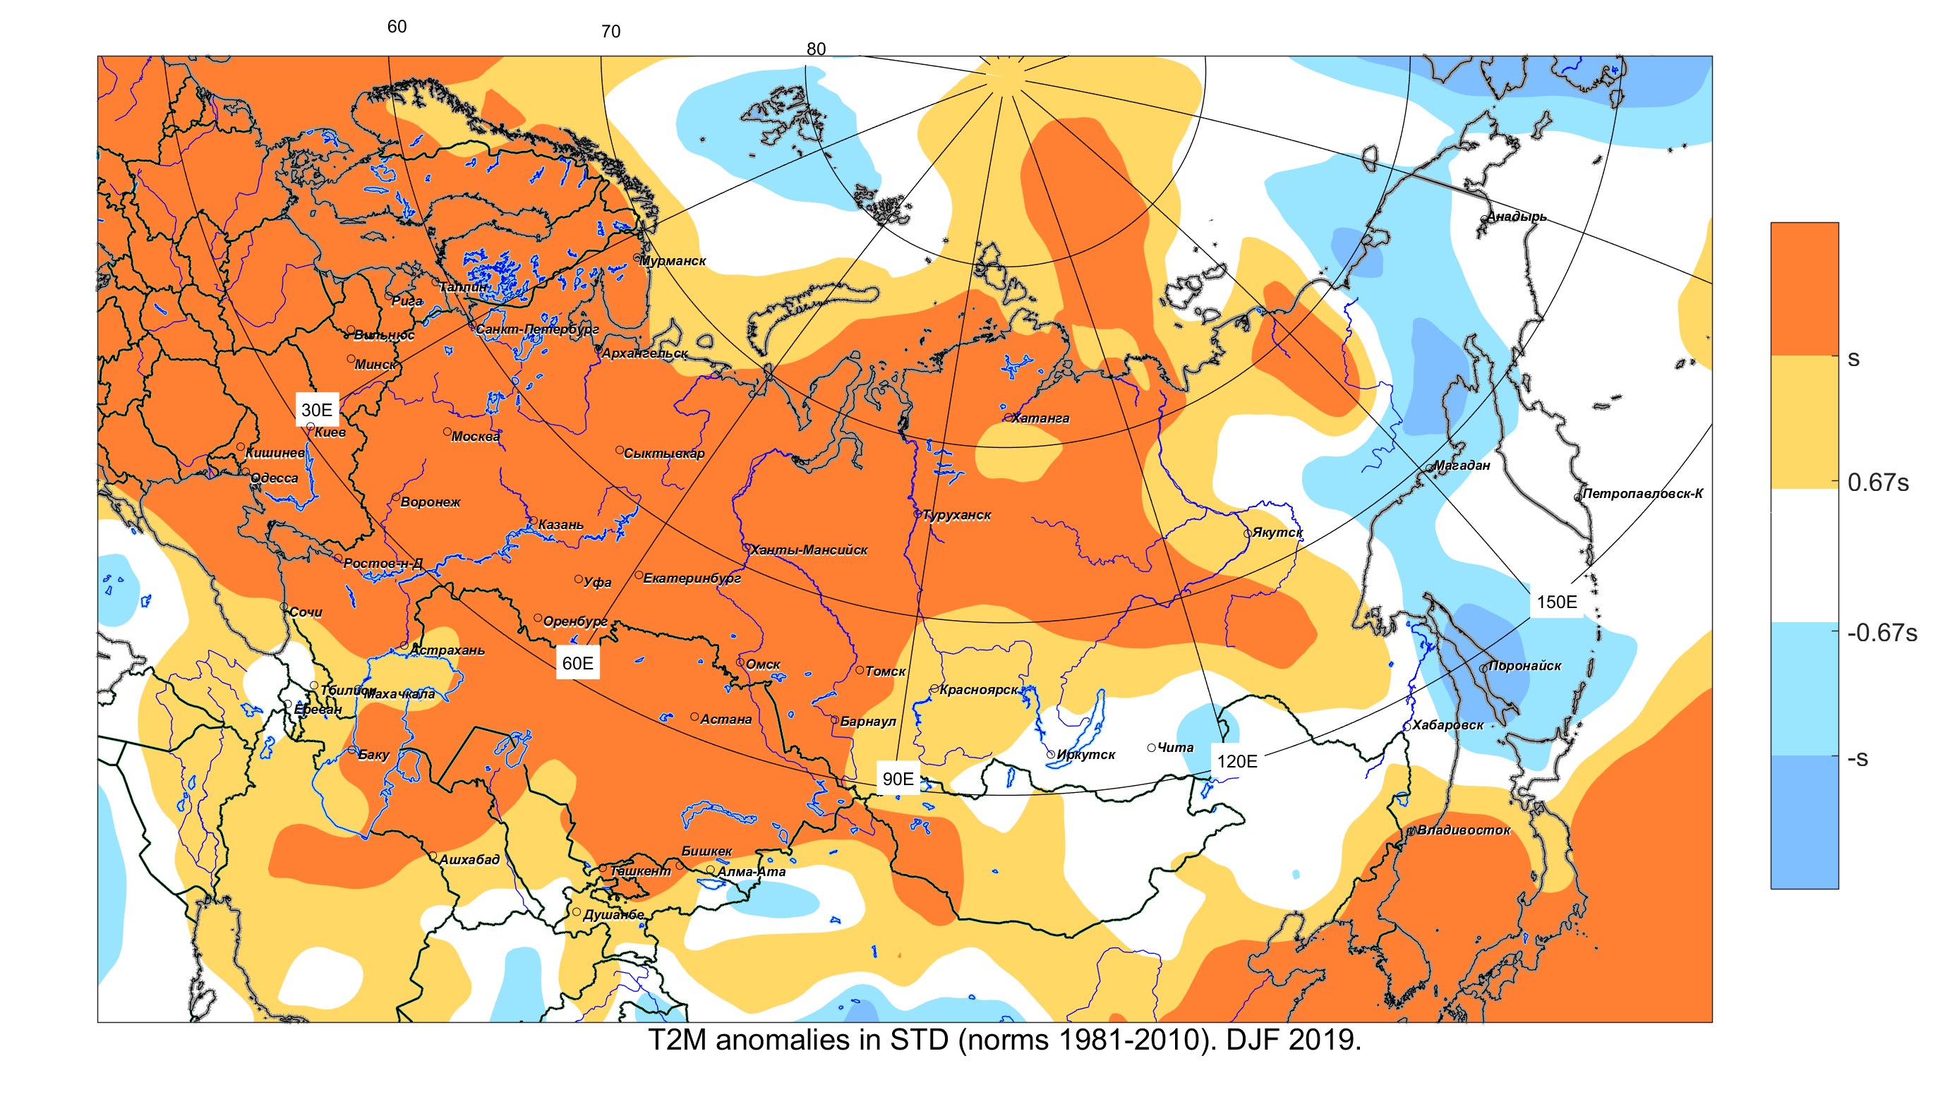  b)
Figure 3. Maps of a) consistency of forecasts of surface air temperature anomalies obtained on the basis of a combination of forecasts from dynamic models (Sl-AV, MGO, TCC, CanSIP, CFS2) b) distribution of surface temperature anomalies from NCEP / NCAR reanalysis, DJF 2019/2020
The consensus forecast has correctly reproduced the abnormal precipitation over the western and northwestern regions of northern Eurasia, in Western Siberia and in Yakutia. Precipitation amounts above the normal value were correctly predicted in Turkmenistan, in Tajikistan, in the western half of Kyrgyzstan, in the central part of Kazakhstan and Uzbekistan (Fig. 4).
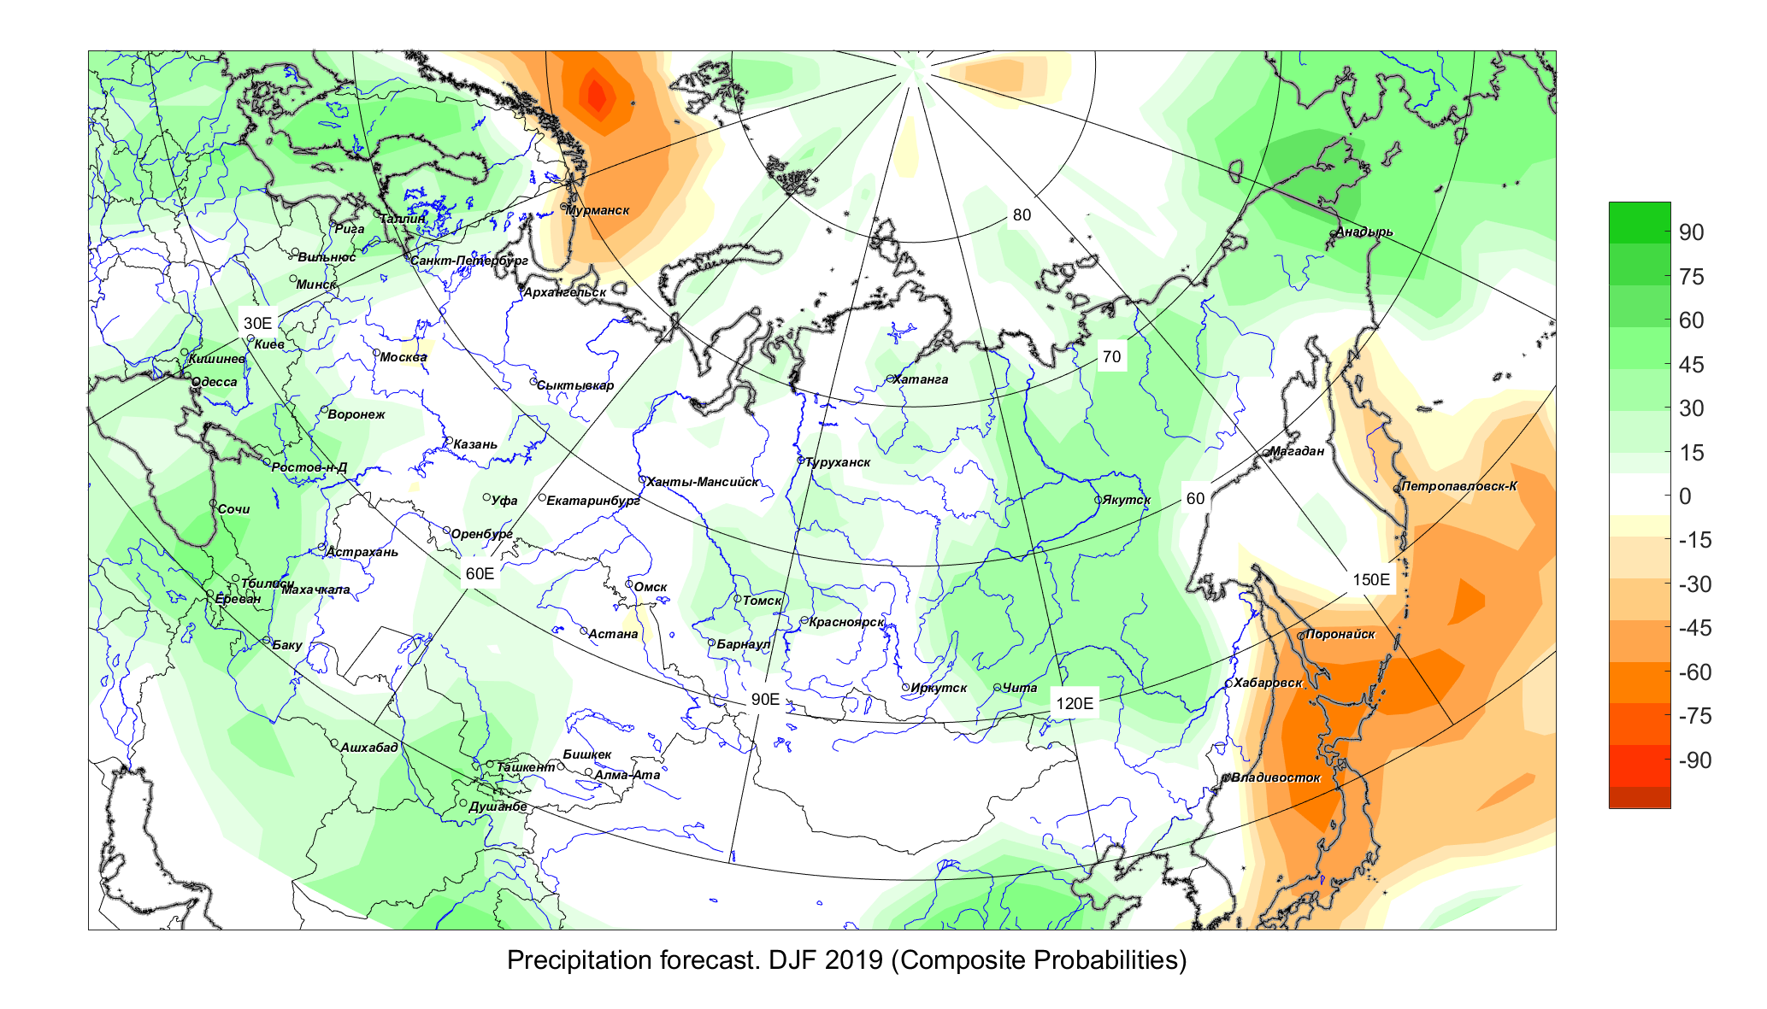 | 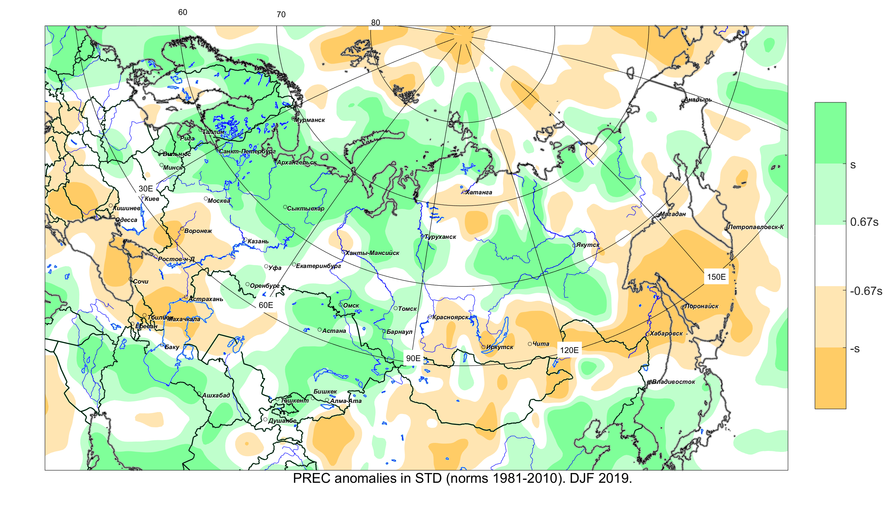
а) б)
Figure 4 Maps of a) consistency of precipitation forecasts on the basis of a combination of forecasts from dynamic models (Sl-AV, MGO, TCC, CanSIP, CFS2) b) distribution of precipitation anomalies from NCEP/NCAR reanalysis, DJF 2019/2020
Skill score of forecasts (%), DJF 2019/2020
 | North Eurasia | European part | Asian part | Central Asia and Kazakhstan
T2m | 71 | 65 | 76 | 67
Prec | 68 | 64 | 70 | 68

The skill score of the consensus forecast over the territory of northern Eurasia was 71% for air temperature and 68% for precipitation. The forecast accuracies for the Asian territory were higher than for the European part.
The main features of the SST and large-scale atmospheric circulation for the JJA 2020.

For upcoming summer 2020, most global forecasting centres predict so high positive anomalies of SST in the North Pacific that the positions of the main patterns of the atmosphere as well as of storm tracks can be remarkably displaced in the Pacific. Weak negative anomalies are expected only in equatorial latitudes, mainly in the east. According to IRI / CPC forecasts, the probabilities of the events of La Nina, the neutral phase and El Nino (Nino3.4, threshold values: -0.5 ° C and 0.5 ° C) in the coming summer season are 17%, 66% and 17%, respectively.

In the north of the Indian Ocean and the adjoining southeast Asia seas, positive temperature anomalies are expected. A decrease in temperature contrasts between land and sea can make the summer monsoon weaker in the subtropical and tropical latitudes of southeast Asia.
In the North Atlantic, the distribution of SST anomalies corresponds to the negative tripole phase associated with the negative NAO phase. Significant positive SST anomalies are expected in the west of tropical latitudes.

Consensus forecast of anomalies in surface air temperature and precipitation for JJA 2020.

The air temperature is expected to be above normal over Siberia and the Far East excluding the southern regions. The highest probability (in excess of 60%) is anticipated over Western Siberia (Fig.5). The forecast uncertatinty for the southern regions of the Asian part is high. Positive temperature anomalies are predicted with a probability of about 40% in Uzbekistan, Turkmenistan, Kyrgyzstan and Tajikistan, and in the southern, western and eastern regions of Kazakhstan. The air temperature forecast signal over largest European part is weak, with possible tendencies to negative anomalies in the northwestern regions. In the southern regions of the European part, the temperature is expected to be above normal with a probability of about 40%.
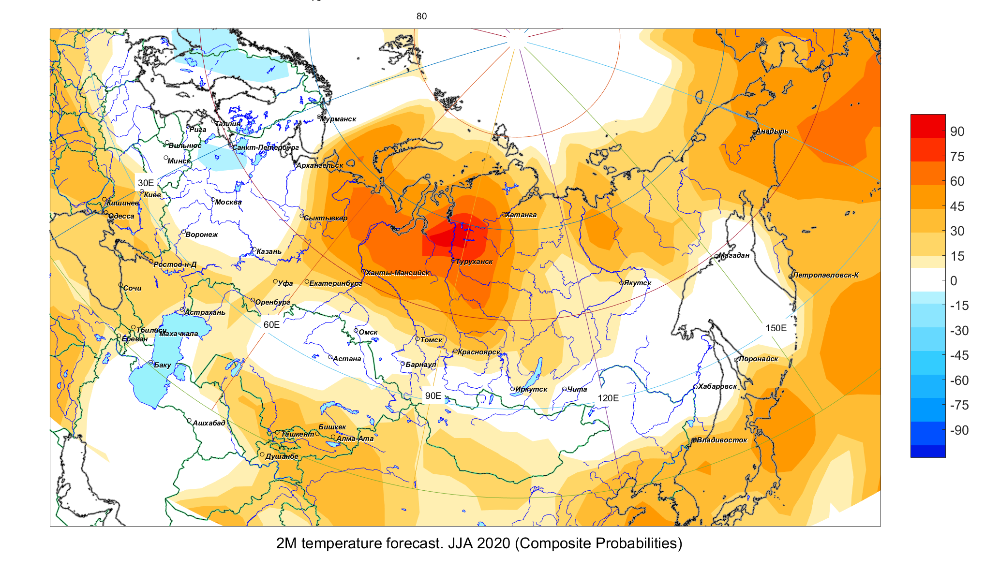
Figure 5. Consistency maps of forecasts based on 5 models ((Sl-AV, MGO, TCC, CanSIP, CFS2). Positive (negative) values (in %) mean the number of models in percentage predicting positive (negative) surface air temperature anomalies.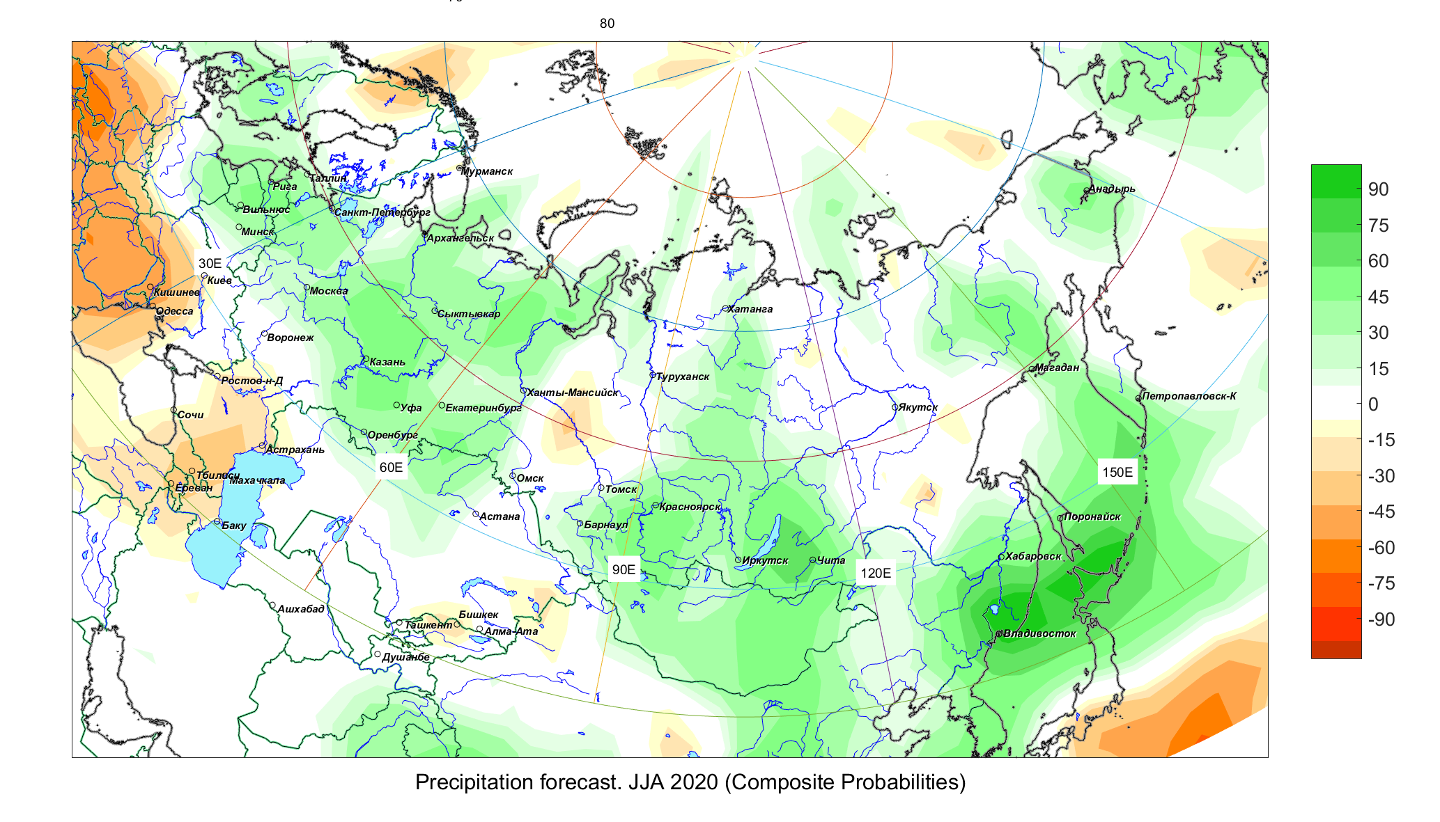
Figure 6. Consistency maps of forecasts based on 5 models (Sl-AV, MGO, TCC, CanSIP, CFS2). Positive (negative) values (in%) mean the number of models in percentage terms predicting positive (negative) precipitation anomalies.
Precipitation amounts near or above the normal ones are expected over a larger territory of the European part and the Ural (Fig.6). In the south of the European part, precipitation is likely to be near and below normal. With a probability of 45-55%, abnormally intensive precipitation has been forecasted for the south of Siberia and the Far East, and for some regions of northeast Russia. In Central Asia and Kazakhstan, the forecast for precipitation is uncertain. Precipitation may possibly be increased in the north of Kazakhstan but meagre in the east.
The consensus forecast is consultative in its character; it can be applied to specific regions taking into account the specific predictability of atmospheric processes, regional climatic features̆ and the quality of hydrodynamic models used.
When using this information, a reference to NEACC is obligatory (http://neacc.meteoinfo.ru)

