Preliminary Outlook for Winter (December-February) 2013-14
(To be revised by mid-November)

Observed and predicted background state of the climate system
1. Oceans
1.1. The state of the ENSO was neutral in mid-October 2013. There were no pronounced SST anomalies in the central and eastern parts of the equatorial Pacific. There was a positive SST anomaly (La-Nina type) in the western equatorial Pacific. Most of the models predict the persistent neutral ENSO state for the whole winter, with the positive SST anomaly in the western equatorial Pacific persisting as well.
1.2. Triple SST pattern in the North Atlantic is weak and does not provide forecast information. Wintertime forecast of the pattern is also of low information.
1.3. Observed and predicted SST anomaly patterns in the North Pacific match the negative phase of PDO.
1.4. Sea ice extent in the Arctic is below normal. A positive SST anomaly is predicted in the eastern North Atlantic and the Barents Sea.
1.5. Summary. In the lack of the strong forcing (p. 1.1) the high variability of circulation and weather condition could be expected.

2. Stratosphere
Highly pronounced western phase of the QBO.

3. Large scale circulation
According to experience, individual model forecast of the large scale seasonal circulation patterns, issued before late October – early November, are rather uncertain. In the lack of the strong forcing (p. 1.1) high uncertainty is combined with the large spread of the individual model forecasts.
From the analysis of indirect predictors it follows:
Positive SST anomaly in the western equatorial Pacific (p. 1.1) is favourable for weakening of the planetary waves 1 and 2, that, in conjunction with the western phase of the QBO (p. 2), may lead to the maintenance of the circumpolar vortex in the stratosphere and zonal circulation in the troposphere.
Meanwhile, the negative anomaly of the sea ice extent in the Arctic (p.1.4) leads to enhanced diabatic heating of the lower troposphere, Rossby wave generation and enhancement of the meridional circulation. Also, a ridge over the eastern North Atlantic may develop due to the positive SST anomaly.
Such different processes should lead to large intraseasonal variations in circulation and varying weather.

Preliminary seasonal prediction of temperature and precipitation is shown in the figures.
Temperature
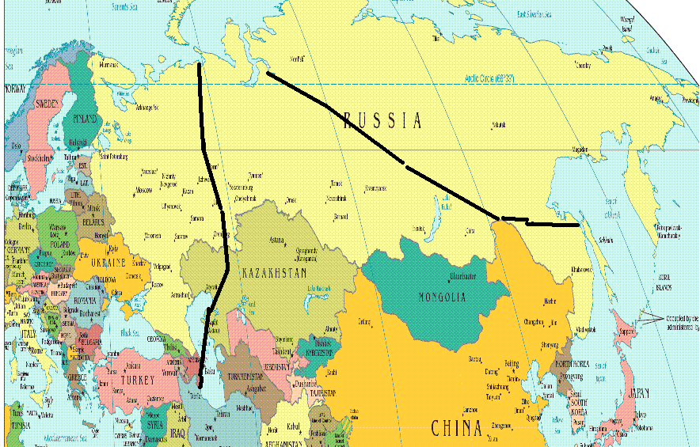
25 / 35 /40
30 / 35 /35
33 / 33 / 33

Precipitation
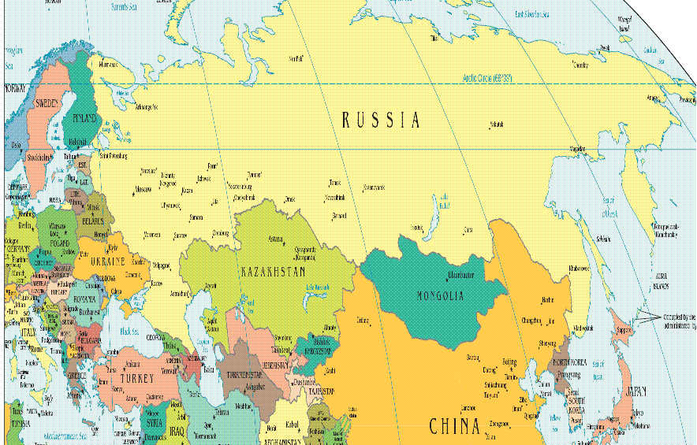
33 / 33 / 33
25 / 35 /40

